

NAME: ABDUL REHMAN(BHATTI)

DEPARTMENT: BS CS(AI)

TO: SIR HAMZA

LAB TASK 05

UNIVERSITY OF WAH

TASK1:

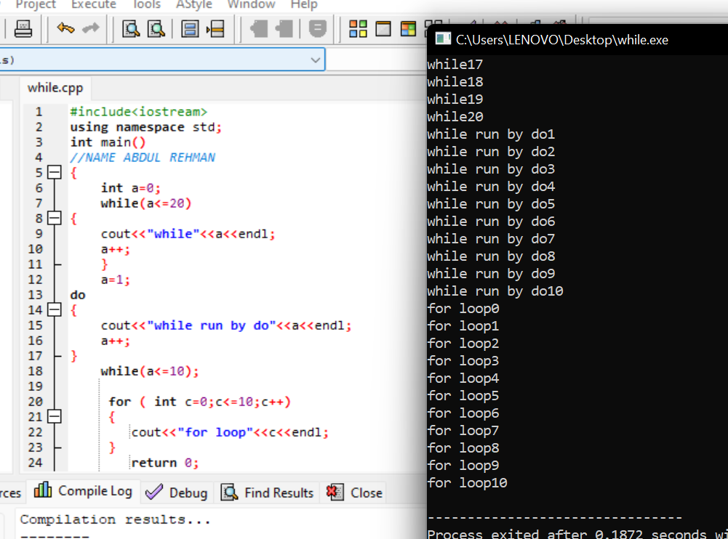

TASK2

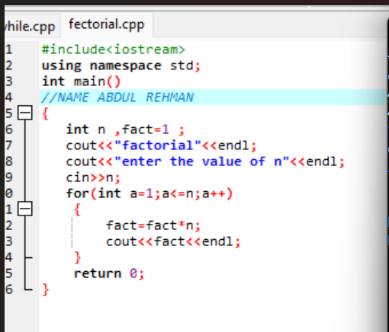

TASK 3

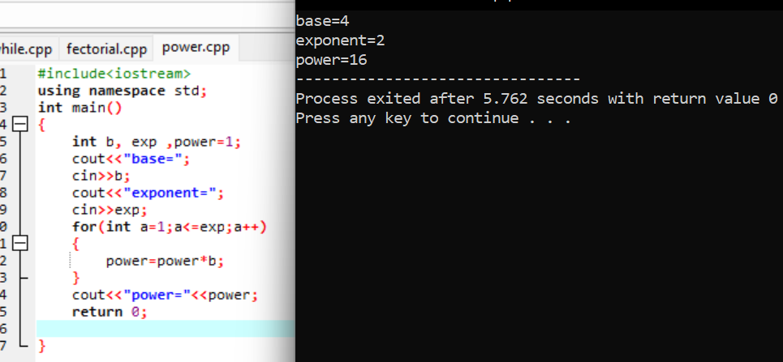

TASK 4

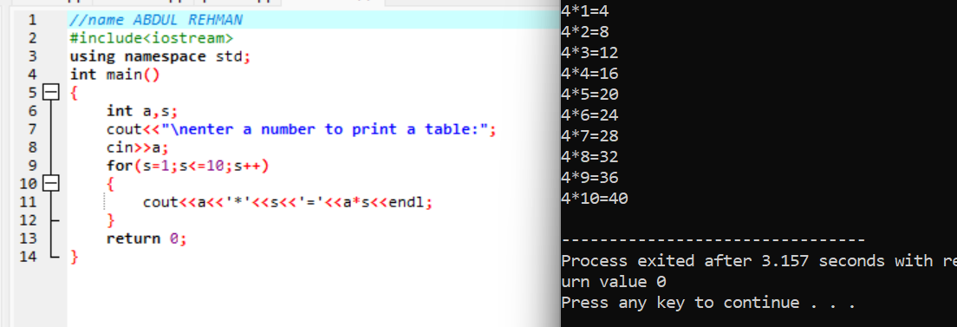

TASK 5

